EXHIBIT "K"

EXHIBIT K-PAGE 1 OF 2

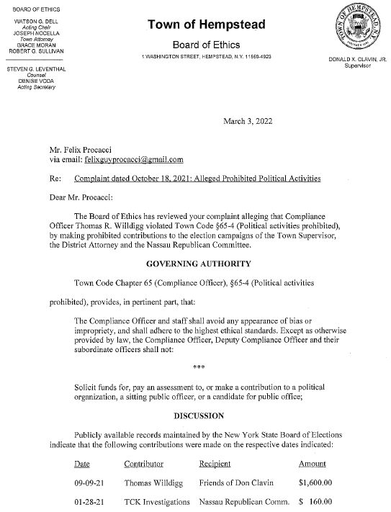

EXHIBIT K-PAGE 2 OF 2

